Vibe Coding Hackathon Workbook
Objective: Build a working MVP in 3 days using vibe coding tools

How to use this
- Pick one product idea from the list here and stick to it.
- Follow Phase 1 → Phase 2 → Phase 3 in order.
- Use any stack: AI Studio / Bolt / Lovable / Replit / Emergent / etc.
- Focus on one strong end-to-end flow, not 20 scattered features.

PHASE 1 - IDEATION
From vague idea to sharp MVP scope

Step 1 - Product and user basics
1.1 Product one-liner
- Product name (working):
__________________________
- One-liner (For X, I am building Y so they can Z):
For ____________________, I am building ____________________ so they can ____________________.
1.2 Who is this for
- Primary user role:
__________________________
- Where they use this (context):
__________________________
- Top 3 pains today:
  - __________________________
  - __________________________
  - __________________________
1.3 MVP success for this hackathon
By the end of 3 days:
- A user should be able to:
_________________________________________________________
- Simple success metric for the demo (one line):
_________________________________________________________

Step 2 - Deepen the problem with 5 Whys
2.1 Problem statement v0
Problem v0:
_________________________________________________________
2.2 5 Whys table
Why # | Question | Your answer
1 | Why is this a problem for your user?
2 | Why does that happen right now?
3 | Why haven’t existing tools solved this well?
4 | Why is your user still stuck?
5 | Why does solving this now matter for them?
2.3 Final problem statement
Final problem statement:
_________________________________________________________
This is the line you reuse in prompts, PRD, and demo.

Step 3 - Competitor scan and AI feature analysis
Screenshots → AI analysis → features list.
3.1 Collect references
Pick 2–3 products closest to what you want to build.
- Take screenshots of key pages:
  - Pricing pages
  - Feature pages
  - Sample UI / dashboards
Product / tool | Links or pages you checked | What they do well  (2 points) | What frustrates users  (2 points)
3.2 AI feature extraction
Paste screenshots or text into your LLM:
“I am building a product similar to these tools: [brief description of each].
Here are screenshots / notes from their feature and pricing pages.
Extract all unique features into a table with columns:
Feature | What it does | Why users care | Which tool(s) have it.
Highlight any patterns and common ‘must have’ features.”
- Where you saved that table (doc / link / file):
_________________________________________________________
Optional: Mark potential differentiators now with a ⭐ in that table.

Step 4 - MVP scope with MoSCoW (core vs differentiators)
4.1 Feature dump
List everything from your head + AI feature table:
- ________________________________
- ________________________________
- ________________________________
- ________________________________
4.2 MoSCoW prioritisation
Use this table and mark differentiators with a ⭐ in the name if needed.
Feature | M (Must) | S (Should) | C (Could) | W (Won't now) | Differentiator? (⭐ / -) | Why you placed it here
 | ☐ | ☐ | ☐ | ☐
 | ☐ | ☐ | ☐ | ☐
 | ☐ | ☐ | ☐ | ☐
Guidance:
- Must: Without it, product fails its main promise.
- Should: Strongly expected, but can live without for v1.
- Could: Candy. Only if time remains.
- Won’t: Explicitly not in this 3-day build.
4.3 Final MVP scope for the hackathon
- Single Must-have flow you commit to ship:
_________________________________________________________
- Up to 2 Should-haves:
  - _____________________________
  - _____________________________
- Features you park deliberately (for later):
  - _____________________________
  - _____________________________

PHASE 1 - END CHECKLIST
- Final problem statement is clear
- Primary user and context defined
- Competitor screenshots + feature table done
- Features prioritised with MoSCoW
- One must-have flow + up to 2 should-haves locked

PHASE 2 - BUILDING
Architecture, PRD, starting prompt, and first build

Step 5 - Architecture: screens, flows, data, backend
5.1 Big picture architecture
- Front-end (what the user sees and clicks):
Screens: ______________________________________________
- Back-end / automations (what runs behind the scenes):
Workflows / services: _________________________________
- Data store (where data lives):
Sheets / DB / built-in storage: _______________________
- External APIs / services (if any):
Email / AI models / webhooks / others: ________________
5.2 Screens & actions table
Screen name | Who uses it | Key actions (buttons / flows) | Data needed / shown
e.g. Task Dashboard | Logged-in user | Create task, update status, mark done | Task title, due date, status, assignee

Step 6 - PRD with AI
Ask Claude to create a proper PRD.
6.1 PRD prompt
Use this in your LLM:
“You are a senior product manager.
I want to build an MVP in a no-code / vibe coding tool.
Problem statement:
[Paste from Step 2.3]
Target user and top 3 pains:
[Paste from Step 1.2].
Prioritised features using MoSCoW (mark differentiators with ⭐):
[Paste your table].
Architecture draft:
- Front-end screens: [list]
- Back-end workflows / automations: [list]
- Data store: [sheet / DB + important fields]
- External services / APIs: [list]
Tasks:
- Write a concise PRD with: Goal, Users, Scope (Must + chosen Shoulds), Out of Scope, Core user flows, Data model (main tables and fields), Non-functional constraints.
- Write a step-by-step build plan for a vibe coding tool.”
6.2 Capture your PRD
- PRD location (doc / link / notes):
_________________________________________________________
- Two key flows to build first:
  - _____________________________
  - _____________________________

Step 7 - Platform optimisation: convert PRD into a starting prompt
Bolt.new best practices → single starting prompt
https://support.bolt.new/building/build-your-first-app.
7.1 Collect platform guidelines
- Chosen tool (Bolt / Lovable / Replit / etc.):
_____________________________
- Link or notes from its “best practices” / docs:
_________________________________________________________
7.2 Starting prompt generator
Use your LLM again:
“Here is my PRD:
[Paste PRD]
Here are best practices / docs for [tool name]:
[Paste key points or link + summary].
Rewrite this PRD as one single starting prompt optimised for [tool name].
- Use the tool’s recommended format.
- Include entities, screens, data model, and must-have flow.
- Keep it copy-paste ready for the builder.”
7.3 Final starting prompt
- Paste your tool-specific starting prompt here or link it:
_________________________________________________________

Step 8 - Day 1 & Day 2 build execution
Day 1 - Outcome
- Complete Phase 1
- Complete Steps 5, 6, 7
- Have a PRD + starting prompt ready
Day 1 checklist:
- Ideation done and frozen
- Architecture sketched
- PRD written
- Tool-specific starting prompt ready
Day 2 - Build the first version
In your chosen tool:
- Create a new project.
- Paste the starting prompt and generate the first version.
- Set up core data model (tables / collections / sheets).
- Ensure the must-have flow is present.
- If parts are missing, use targeted prompts to:
  - Add missing screens
  - Fix obvious UI gaps
  - Align flows with PRD
Day 2 checklist:
- Project created in tool
- First build generated from starting prompt
- Data model exists
- Must-have flow runs at least once end-to-end (even if rough)

OPTIONAL SECTION - GITHUB FOR BACKUP & COLLAB
(Use only if your team wants shared code)
Goal:
Keep your code in one place and let everyone update it.
This is a simple path: one main branch, small commits, no complex Git.
Step G1 - One repo per team
- One teammate goes to github.com → New repository.
- Name it: aiap-<cohort>-<team-name> or similar.
- Visibility: Private is fine.
- Click Create repository.
Step G2 - Add collaborators
- In the repo, go to Settings → Collaborators.
- Add your teammates by GitHub username or email.
- Give them Write access.
Now everyone can open the same repo.
Step G3 - Simple “back code and collaborate” workflow
Use this pattern during the hackathon:
- One person is Code Owner for the repo.
- Others send code snippets or files to Code Owner (from Bolt / editor export).
- Code Owner:
  - Pulls latest code from GitHub (if using Git) or edits in web UI.
  - Pastes / uploads updated files.
  - Clicks Commit with a clear message:
    - “Add itinerary screen”
    - “Fix activity edit flow”
Repeat this whenever a feature is stable.
Team rules (keep it simple):
- Only commit working code.
- One person commits at a time.
- If something breaks, Code Owner reverts last change or fixes and commits again.
- Github Guide for additional information : GitHub Guide 101

PHASE 2 - END CHECKLIST
- Architecture clear and documented
- PRD complete
- Tool-optimised starting prompt created
- First build live with must-have flow in place
- Backup on github

PHASE 3 - BACKEND, AUTOMATIONS, ITERATION & DEMO
Database implementation, CRUD, testing, and enhancement.

Step 9 - Database and CRUD
9.1 Data design
- Primary entities (e.g. Tasks, Projects, Users):
  - __________________________
  - __________________________
For each, define:
- Table / collection name: __________________________
- Fields:
_________________________________________________________
9.2 CRUD checklist
For each core entity, check if you support:
Entity | Create | Read / list | Update | Delete | Notes / gaps
 | ☐ | ☐ | ☐ | ☐
 | ☐ | ☐ | ☐ | ☐
If any box is unchecked:
- Write a prompt to your tool / LLM:
“Enable full CRUD for [entity] in my app.
Add screens / actions for [missing operations].
Keep UX consistent with existing screens.”

Step 10 - Automations and AI enhancements
This covers things like AI Task Breakdown, notifications, etc.
10.1 Backend & automations table
Trigger (event) | Tool / service | What should happen
User signs up / first login | e.g. n8n / built-in | Create user record, send welcome email, log to sheet
User creates a main item |  | Save item, optionally run AI Task Breakdown
User completes a workflow |  | Send summary email / notification / log to history
Fill this for your product:
Trigger (event) | Tool / service | What should happen
10.2 Optional “wow” AI feature
Pick one small enhancement (example: AI Task Breakdown):
- Feature name:
_________________________________________________________
- What it does in one line:
_________________________________________________________
- Prompt or config notes for it:
_________________________________________________________

Step 11 - Testing and iteration loop
test → see missing edit/delete → prompt → fix → retest.
11.1 Scenario test script
Define one realistic scenario:
“User type [X] wants to [goal].
They will go through: [screen 1] → [screen 2] → [screen 3] → done.”
Describe it:
_________________________________________________________
11.2 Bug and gap log
While testing, log issues:
# | What broke / missing (issue) | Where (screen / flow) | Prompt you used to fix it | Fixed? (Y/N)
1
2
3
Cycle:
- Run the scenario end-to-end.
- Write down each issue.
- Use targeted prompts to the builder to fix.
- Retest.
11.3 Stability checklist
- Must-have flow works start to finish at least twice in a row
- No obvious dead buttons or dead-end screens
- CRUD works for main entities
- Key automation(s) fire as expected

Step 12 - Demo and reflection
12.1 Demo script (3–5 mins)
Fill this and use it as your narration:
- User and problem:
“Our product is for ____________________ who struggle with ____________________.”
- What you built:
“In 3 days, we built ____________________ so they can ____________________.”
- Live walkthrough:
  - Start from entry point.
  - Run the must-have flow end-to-end.
  - Show the one wow AI/automation detail.
- Close:
  - “Next, we plan to ____________________.”
Demo checklist
- Clear entry path (login or shared URL)
- Must-have flow runs live without hidden setup
- Wow feature works on demo data
12.2 Reflection after the hackathon
- What users / judges liked most:
_________________________________________________________
- One product / design choice that worked well:
_________________________________________________________
- Top 3 issues you noticed:
  - __________________________
  - __________________________
  - __________________________
- Next 7-day plan:
  - Improve stability and UX
  - Add 1–2 parked features
  - Test with 3–5 real users
  - Clean PRD and architecture for v2

Resources
- Pitch Deck Template: AIAP : Pitch Deck Template
- Product Ideas: Product Ideas for Accelerator
- Loom for recording: https://www.loom.com/
How to Submit Your Project

Step 1: Open the Project Submission Portal
Visit the portal below:
AI Accelerator Hackathon Portal

Step 2: Navigate to the Submission Page
- Log in to the portal
- Click on the "Submit Project" tab at the top of the page
- Review the submission requirements listed on the page

Step 3: Keep These Ready Before Submitting
Make sure you have the following:
✅ Live product link
✅ 2–3 minute Loom walkthrough video
✅ Pitch deck (using the provided template)
✅ Team details

Step 4: Submit Your Project
- Click on "Submit Project"
- Fill in all the required details
- Submit the form

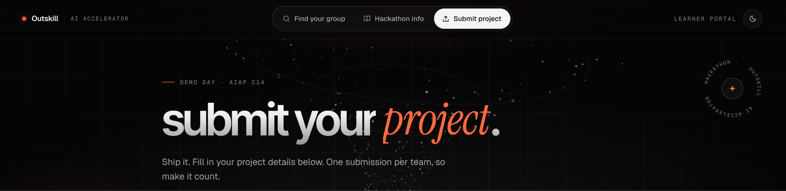
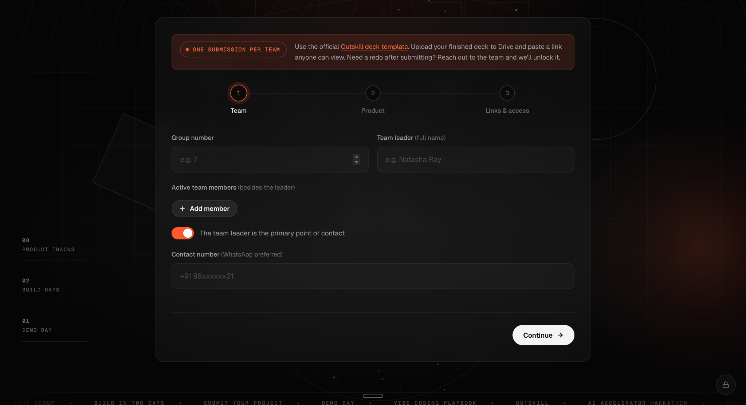

Important
⚠️ Project submissions will be accepted only through the Project Submission Portal.
⚠️ Submissions shared in WhatsApp groups, emails, or any other channel will not be considered valid.
⚠️ Ensure all details are entered correctly before submitting, as the submitted information will be used for evaluation.

